AGENDA FOR THE EXTRA ORDINARY MEETING OF ASTLEY ABBOTTS PARISH COUNCIL HELD ON
WEDNESDAY APRIL 29TH 2026 AT 7.30PM In Village Hall Cross Lane Head.

- Public Session:
- Acceptance of Apologies:
- Dispensations:
- Destruction of works for Defibrillator Panel and Box.
- Land ownership.
- Report from clerk on actions so far.
- Next steps. 1. Siting of defibrillator on car park.
- Annual Parish Meeting date rethink.
9. Date of the next scheduled Tuesday 12th May 2026.

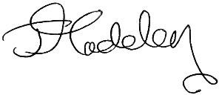

clerk@astleyabbotts-pc.co.uk

SJE

Simon Elcock Chair.

